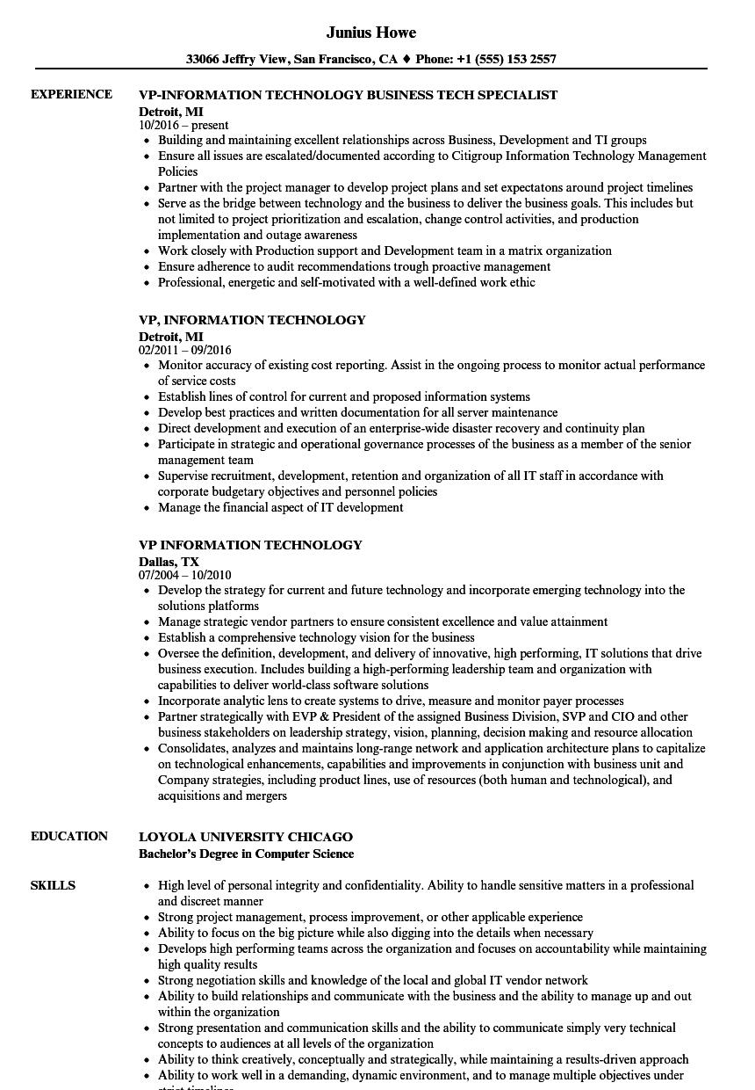
EXPERIENCE
EDUCATION
SKILLS
Junius Howe
33066 Jeffry View, San Francisco, CA ♦ Phone: +1 (555) 153 2557
VP-INFORMATION TECHNOLOGY BUSINESS TECH SPECIALIST
Detroit, MI 10/2016-present
• Building and maintaining excellent relationships across Business, Development and TI groups
• Ensure all issues are escalated/documented according to Citigroup Information Technology Management Policies
• Partner with the project manager to develop project plans and set expectatons around project timelines
• Serve as the bridge between technology and the business to deliver the business goals. This includes but not limited to project prioritization and escalation, change control activities, and production
implementation and outage awareness
• Work closely with Production support and Development team in a matrix organization
• Ensure adherence to audit recommendations trough proactive management
• Professional, energetic and self-motivated with a well-defined work ethic
VP, INFORMATION TECHNOLOGY
Detroit, MI
02/2011 09/2016
• Monitor accuracy of existing cost reporting. Assist in the ongoing process to monitor actual performance of service costs
• Establish lines of control for current and proposed information systems
• Develop best practices and written documentation for all server maintenance
• Direct development and execution of an enterprise-wide disaster recovery and continuity plan
• Participate in strategic and operational governance processes of the business as a member of the senior management team
• Supervise recruitment, development, retention and organization of all IT staff in accordance with corporate budgetary objectives and personnel policies
• Manage the financial aspect of IT development
VP INFORMATION TECHNOLOGY
Dallas, TX
07/2004 - 10/2010
• Develop the strategy for current and future technology and incorporate emerging technology into the solutions platforms
• Manage strategic vendor partners to ensure consistent excellence and value attainment
• Establish a comprehensive technology vision for the business
• Oversee the definition, development, and delivery of innovative, high performing, IT solutions that drive business execution. Includes building a high-performing leadership team and organization with capabilities to deliver world-class software solutions
⚫ Incorporate analytic lens to create systems to drive, measure and monitor payer processes
⚫ Partner strategically with EVP & President of the assigned Business Division, SVP and CIO and other business stakeholders on leadership strategy, vision, planning, decision making and resource allocation
• Consolidates, analyzes and maintains long-range network and application architecture plans to capitalize on technological enhancements, capabilities and improvements in conjunction with business unit and Company strategies, including product lines, use of resources (both human and technological), and acquisitions and mergers
LOYOLA UNIVERSITY CHICAGO
Bachelor's Degree in Computer Science
• High level of personal integrity and confidentiality. Ability to handle sensitive matters in a professional and discreet manner
• Strong project management, process improvement, or other applicable experience
• Ability to focus on the big picture while also digging into the details when necessary
• Develops high performing teams across the organization and focuses on accountability while maintaining high quality results
• Strong negotiation skills and knowledge of the local and global IT vendor network
• Ability to build relationships and communicate with the business and the ability to manage up and out within the organization
• Strong presentation and communication skills and the ability to communicate simply very technical concepts to audiences at all levels of the organization
• Ability to think creatively, conceptually and strategically, while maintaining a results-driven approach
• Ability to work well in a demanding, dynamic environment, and to manage multiple objectives under

